1915 LED four-color moving head light

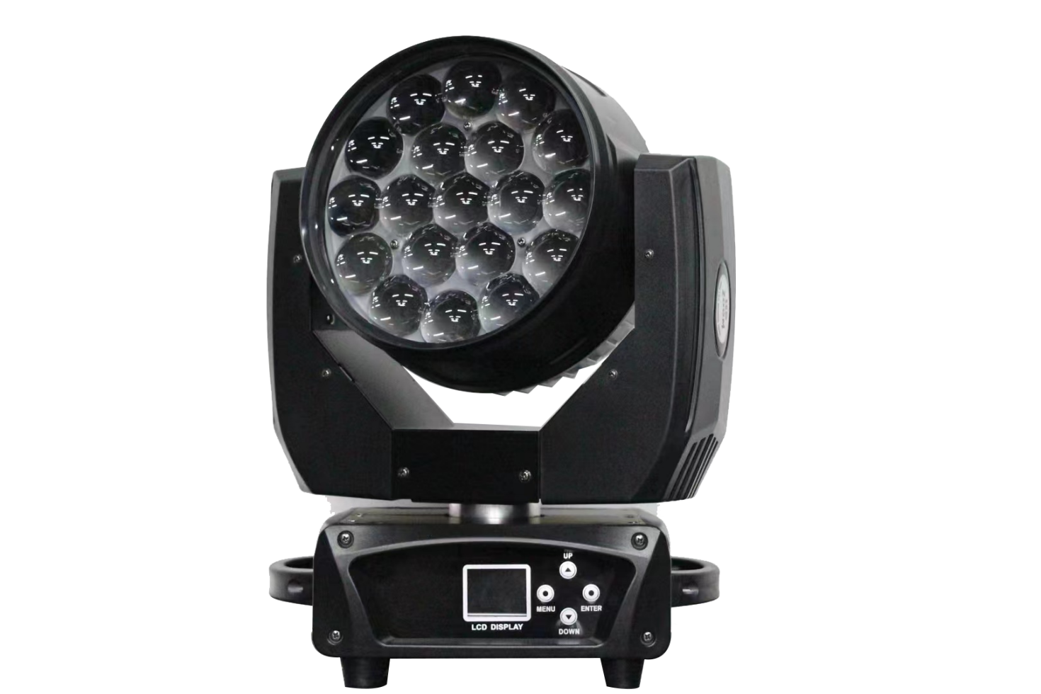

Thank you for using the product produced by our company. In order for you to use this product safely and effectively, please read this user manual carefully and completely before using it. This manual includes the performance and safety instructions of the product, as well as important information on how to install and use it safely. Please keep it properly for reference during use. Please strictly follow the relevant instructions during installation and use

Technical parameters:
Power supply: AC100V-240V
Frequency: 50Hz-60Hz
Total power: 320W
Fuse: 7A
Lamp source power: 250W
Color temperature: 8500K
Average lifespan: 2000H
Control signal: International standard DMX512
Appearance: High temperature resistant plastic+molded alloy material
Lamp body color: black
Protection level: IP20
Net weight of 11.KG

Function Introduction:
1. International standard control signal: DMX512
2. Number of channels: 15CH/24CH
3. Number of motors: 3 silent motors in total
4. LCD interface, easy to operate, beautiful interface, and the interface can be reversed 180 degrees for display.
5. Horizontal rotation of the X-axis at 540 ℃, vertical rotation of the Y-axis at 270 ℃, with automatic calibration positioning
6. The X and Y axes can be adjusted and micro tuned, and the software has calibration and positioning functions, with high accuracy!
7. Dimming: 0-100% linear adjustment
8. Strobe: Strobe speed (1-30 times/second), fully linear dimming and variable flicker speed
9. Focusing: Using an optical combination, the effect far exceeds that of typical dyeing lamps, and can project high-definition effects
10. Overheating intelligent protection
11. Intelligent dimming control (extending the service life of the light source)

Connection of DMX512 signal:
This lamp uses the DMX512 signal control mode, and the control signals of each lamp are in parallel. When connecting multiple lamp signals, it is best to use a dual core shielded cable. When connecting, each lamp is connected through the DMX signal socket (XLR socket) INPUT and OUTPUT on the lamp. The 3-core XLRXL plug terminals of the signal line connected to the lamp must correspond to each other. When connecting lamp signals, it is recommended to use a DMX signal terminator. This can avoid damaging the control signal due to electrical noise. The DMX signal terminator is an XLR plug with a 120 ohm 1W resistor connected between pin 2 and pin 3, and connected to the OUTPUT of the last lamp. On the (output) socket

Installation instructions for lighting fixtures:
This lamp can be placed horizontally, hung diagonally or upside down. When hanging diagonally or upside down, be sure to pay attention to the installation method
1. Fixed installation of lighting fixtures: Before positioning the lighting fixtures, it is necessary to ensure the stability of the installation location. When reversing the hanging installation, it is necessary to ensure that the lighting fixtures do not fall off the support frame. Safety ropes should be used to pass through the support frame and lighting fixture handle for auxiliary hanging; To ensure safety and prevent the lamp from falling and sliding, pedestrians are prohibited from passing underneath during installation and commissioning. Regular inspections are conducted to check for wear on safety ropes and loose hook screws. The manufacturer shall not be held responsible for any consequences resulting from the lamp falling due to unstable hanging installation
Safety reminder!
To ensure your safe and correct use of the lighting fixtures, please carefully read the following safety tips before use to avoid unnecessary malfunctions and injuries
1. Non professionals are not allowed to disassemble lamps and accessories inside the lamps without authorization
2. AC power supply: Check if the local power supply meets the rated voltage requirements of the product.
3. This lamp is designed according to the type of electric shock protection. The lamp must be connected to a fully grounded power supply system, and the ground wire of the lamp must be connected to the ground wire of the power supply system. Do not use power cords with damaged insulation layers, and do not overlap the power cords with other wires
When installing and positioning the lamp, any point on the surface of the lamp should maintain a minimum distance of 10 meters from any flammable or explosive material, and a distance of 2.5 meters from the illuminated object. Please do not directly install the lamp on the surface of flammable materials
5. The ambient temperature for the use of the lamp is (-10 degrees+40 degrees), with a maximum surface temperature of 80 degrees. The lamp should be kept away from liquid substances and humid environments
6. Before using the lighting fixture, it is necessary to ensure that the fixture is well grounded and that no parts of the fixture are installed or disassembled with electricity
7. When installing lighting fixtures, make sure to tighten the fixing screws and add safety ropes, and check them regularly
8. It is recommended that the continuous working time of the lamp should not exceed 10 hours, and the interval between continuous starting of the lamp should not be less than 10 minutes. Otherwise, it may not trigger properly due to overheating protection of the bulb
During use, if there are any abnormalities in the lighting fixtures, they should be stopped in a timely manner
When the light bulb reaches its rated service life, it should be replaced in a timely manner, otherwise there may be a dangerous accident of bursting bubbles
11. The rotating parts and adhesive accessories of the lighting fixtures must be regularly inspected. If they become loose or shake, they should be reinforced in a timely manner to prevent accidents
12. The lighting fixtures use strong wind cooling, which is prone to dust accumulation. They must be cleaned once a month, especially the cooling vents, otherwise they may be blocked by dust accumulation, resulting in poor heat dissipation and abnormal lighting fixtures

Maintenance and Preservation:
Shutdown operation: Before each power outage, turn off the light source in advance. Let the cooling fan quickly dissipate the heat generated inside the lamp during use, which can extend the service life of the accessories inside the lamp, especially the light source! To ensure the stable operation of the lamp, it should be kept clean. Before disassembling the lamp for maintenance or starting maintenance work, it is important to confirm whether the power is disconnected. Keeping the lamp clean and tidy is very important. Please clean it regularly, not only to maintain maximum brightness output, but also to extend the service life of the lamp. It is recommended to use high-quality glass cleaner and clean soft cloth for cleaning. Use a vacuum cleaner to clean the inside of the lamp at least once every six months

after-sale service
be careful! When the lamps leave the factory, they undergo strict quality inspection and the packaging is intact. Please operate them according to the user manual
Machine malfunctions caused by human error are not covered by warranty
1. Our company provides lifelong technical consultation to customers
If the product malfunctions and requires repair, please present the product warranty card and truthfully fill in the relevant information. At the same time, we also hope that customers can promptly provide us with feedback on the problems with the product, so that we can make improvements to the product as soon as possible.
In addition to lighting fixtures, the following accessories can also be optionally selected:
Attachment: 1 power cable, 1 signal cable, 1 instruction manual

Optional parts
Lamp source (according to customer requirements)
Lamp hook safety rope (according to customer selection)

Menu operation
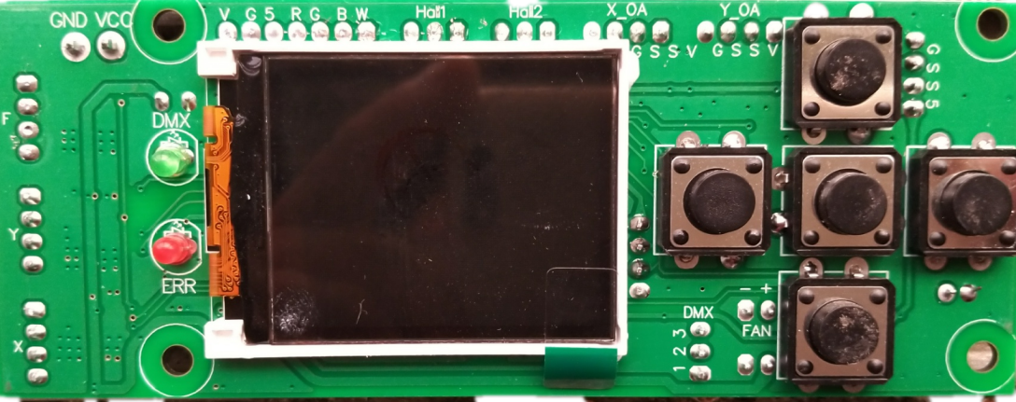
Settings interface
UP

Enter
Back/Menu
System error indication
Signal indicator light
DOWN

There are four primary menus: system settings, operating mode, display settings, and factory settings. The operation is simple and the response speed is fast.
Menu Description
System settings
1. Confirm the modification of DMX address 002 with the confirm button, select the DMX address with the up and down keys, confirm again, and return to exit..
2. Close the encoder by pressing the confirm button to confirm the modification, then select close/open up and down, confirm again, and return to exit
3. Reverse X to close. Confirm the modification by pressing the confirm button, then select close/open up or down, confirm again, and return to exit.
4. Reverse Y to close. Confirm the modification by pressing the confirm button, then select close/open up or down, confirm again, and return to exit.
Operation mode
The operation mode of DMX can be confirmed and modified by pressing the confirm button, selecting the operation mode by pressing the up and down buttons, confirming again, and returning to exit.
Channel selection 16CH

Boundary setting
Language selection: Chinese. Confirm the modification by pressing the confirm button, select the language by pressing the up and down buttons, confirm again, and return to exit.
To turn off the reverse display setting, confirm the modification by pressing the confirm button, select open by pressing the up and down buttons, confirm again, and return to exit.

Factory settings (password 138)
calibration
X Calibration 128: Confirm the modification by pressing the confirm button, then select the appropriate channel value up and down, confirm again, and return to exit
Y Calibration 128: Confirm the modification by pressing the confirm button, then select the appropriate channel value up and down, confirm again, and return to exit
Focus 128: Confirm the modification by pressing the confirm button, then select the appropriate channel value up and down, confirm again, and return to exit
Red 220: Confirm the modification by pressing the confirm button, then select the appropriate channel value up and down, confirm again, and return to exit
Confirm the modification with the green 220 button, then select the appropriate channel value up and down, confirm again, and return to exit
Confirm the modification with the blue 220 button, then select the appropriate channel value up and down, confirm again, and return to exit
Confirm the modification with the white 220 button, then select the appropriate channel value up and down, confirm again, and return to exit
Logo 000 Confirm first using the left function key, then select the appropriate logo up and down, confirm again, and return to exit

16-channel mode：
channel |  | 16
1 | 000-255 | X-axis (horizontal)
2 | 000-255 | Y-axis (vertical)
3 | 000-255 | XY speed
4 | 000-255 | Total dimming
5 | 000-255 | Red brightness adjustment
6 | 000-255 | Green brightness adjustment
7 | 000-255 | Blue brightness adjustment
8 | 000-255 | White brightness adjustment
9 | 000-255 | Strobe light
10 | 000-255 | focusing
11 | 000-255 | Functional mode
12 | 000-255 | Mode speed
13 | 000-255 | X-axis fine-tuning
14 | 000-255 | Y-axis fine-tuning
15 | 000-255 | 000-249 invalid 250-255 reset
16 | 000-255 | Color temperature
24-channel mode：
channel |  | 24
1 | 000-255 | X-axis (horizontal)
2 | 000-255 | Y-axis (vertical)
3 | 000-255 | XY speed
4 | 000-255 | Total dimming
5 | 000-255 | Red 1 brightness adjustment
6 | 000-255 | Green 1 brightness adjustment
7 | 000-255 | Blue 1 brightness adjustment
8 | 000-255 | White 1 brightness adjustment
9 | 000-255 | Red 2 brightness adjustment
10 | 000-255 | Green 2 brightness adjustment
11 | 000-255 | Blue 2 brightness adjustment
12 | 000-255 | Brightness adjustment for white 2
13 | 000-255 | Red 3 brightness adjustment
14 | 000-255 | Green 3 brightness adjustment
15 | 000-255 | Blue 3 brightness adjustment
16 | 000-255 | White 3 brightness adjustment
17 | 000-255 | Strobe light
18 | 000-255 | focusing
19 | 000-255 | Functional mode
20 | 000-255 | Mode speed
21 | 000-255 | X-axis fine-tuning
22 | 000-255 | Y-axis fine-tuning
23 | 000-255 | 000-249 invalid 250-255 reset
24 | 000-255 | Color temperature

